**Business**  **Process** Documentation

**Nusantara Application Certification (NAS)**

**Website TUK**



|  |
| --- |
| Prepared by: |
| **PT. Nusantara Success Technology**  Jl. Jati Murni No. 30, Jati Padang, Sunday Market  South Jakarta 12540 |



# **Document** version

|  |  |  |  |
| --- | --- | --- | --- |
|  |  |  |  |
| Document Description | 1st Publish |  |  |
| Document Status | Draft verses |  |  |
| Document Change history |  |  |  |
| Date | Created by | Verses | Description of changes |
| 24 February 2020 i | Dap | 1.1 | Initial version of NAS (Website TUK) V. 1.1 |
|  |  |  |  |
|  |  |  |  |
|  |  |  |  |
|  |  |  |  |
|  |  |  |  |

# **Approval** page

|  |  |  |  |
| --- | --- | --- | --- |
| **PT. Nusantara Sukses Teknologi** | | **Pt. Nusantara Sertimedia Application** | |
| Prepared by: | Approved by: | Review by: | Approved by: |
| Rr.Dhianita Apriany T |  |  |  |
| Date: | Date: | Date: | Date: |

Nusantara Application Certification

Business Process Documentation

This document is used to describe the workflow and business process of Nusantara certification Applications (NAS), especially the TUK website. Dokumen This document is an Advanced version of the previousversion, which is version 1.1 (Minimum Viable Product).

# Flow Diagram

In this section is explained about the flow/ business processes occurring in the NAS application as a whole, including the website TUK.

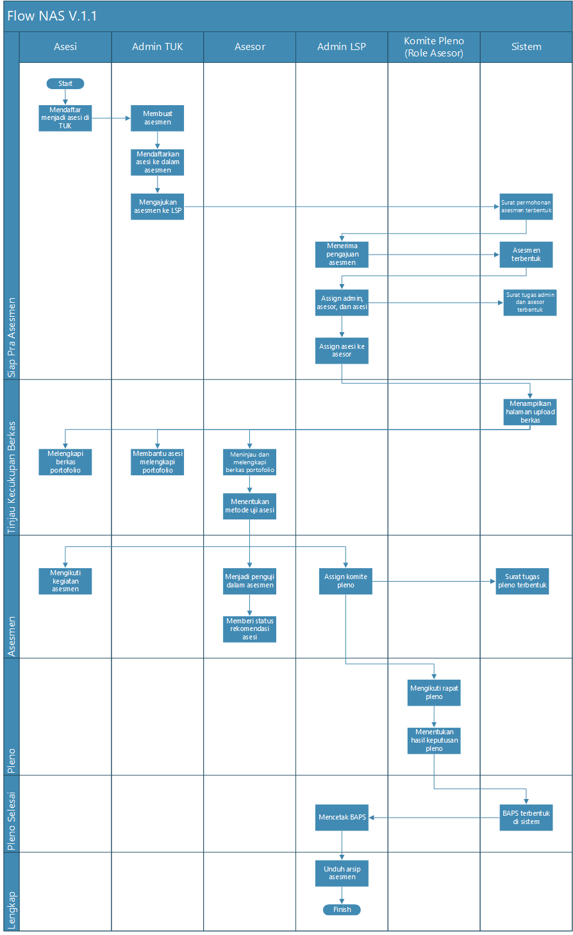

## Description

|  |  |  |
| --- | --- | --- |
| **Nama Use Case** | **Description of Use Case** | **Lead actor** |
| Sign up to be and in TUK | As a first step , and enroll in TUK. | And |
| Creating Assessment | The Admin TUK creates the assessment and selects the desired scheme and schedule . | Admin TUK |
| Registering the and into the Assessment | Admin TUK Register any and who will follow The assessment activities . In this process ini, the TUK admin can also include an and that does not have an account (non account user). | Admin TUK |
| Submitting Assessment to LSP | The telah Admin TUK submits previously created assessment to the LSP. After this, the application letter of assessment will be formed in the system. | Admin TUK |
| Receiving assessment Submission | LSP Admins Accept the application of TUK assessment . | Admin LSP |
| Assign Admins, assessors, and and | LSP Admins Assign admins, assessors, and also and that will follow the assessment. After this, the admin task letter and the Mail task assessment will be formed in the system. | Admin LSP |
| Assign and to the assessor | LSP Admins pair the and to its accessories. | Admin LSP |
| Complete the portfolio file | Asesi is required to complete the portfolio file . The Portfolio is divided into two, General terms and persyaratan basicrequirements. | And |
| Helping and complement portfolios | Admin TUK can help complement the and portfolio file . | Admin TUK |
| Review and complement the portfolio file | Asesor serves to review The completeness of the and file, and can also help to complement its files if needed. | Advisor |
| Determine the and test Method | Asesor determines the test method for and, the yaitu method of testing the portfolio and competence. | Advisor |
| Following assessment Activities | Asesi following the assessment activities that have been scheduled in advance, according to the scheme chosen. | And |
| Become Testers in the assessment | Assessors become testers in the assessmentactivities. | Advisor |
| Assign the Plenary Committee | LSP Admins assign the Plenum Committee , which comprises the chairman of the plenary and anggota Plenarymembers. The Role of the plenary Committee is the Assessor, but should not be the same as the assessors that test in the assessment. After this Plenary task will form in the system. | Admin LSP |
| Give status recommendation of and | Asesor give status recommended or not recommended for and, as a consideration material during Plenarymeetings. | Advisor |
| Join a Plenary meeting | The plenary Committee follows a plenary meeting to determine whether the and is competent or yet competent. | Plenary Committee |
| Determining the results of Plenary decisions | The Plenary Committee issued a Plenary decision for the and. | Plenary Committee |
| Mencetak BAPS | LSP Admins print the news Publishing event certificate. | Admin LSP |
| Download Assessment Archive | The LSP Admin can download the Assessment archive , which contains all data related to the assessment . Including mail, files, etc. | Admin LSP |

Use Case Diagram

In this section will be described the Authority of each user involved. Here 's a user rights Chart on the aplikasi NAS app as a whole, where there is a TUK website in it :

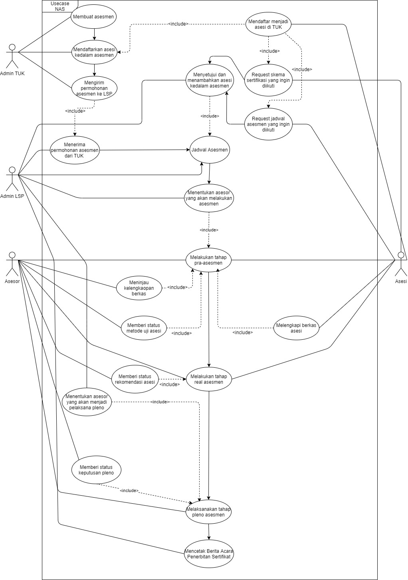

## Admin TUK



Users who play a role in Tuk website are the Tuk admins . As for admin TUK can do the-proses followingprocesses:

1. Instruct and to download the application and melakukan Register on the application and.
2. Create the assessment.
3. Registering the and into the assessment, whether already have an account or not.
4. Submit an Assessment schedule to LSP.
5. Assisting the completeness of the and portfolio file (uploading files) if needed.

## List of Menu/ features

|  |  |  |  |
| --- | --- | --- | --- |
| **No** | **Menu name/**  **feature** | **Description** | **PIC** |
| 1. | Home | Displays a dashboard containing information related to the assessment information , and, and the ser-certification scheme . | Admin LSP |
| 2. | Data Asesi | Displays the and data that will follow the assessment. In Thismenu, the TUK Admins can add and edit data and. | Admin LSP |
| 3. | Assessment | In thismenu, the TUK admin can create the assessment, and add the and that does not have the account (mobile) into theassessment.  After that, THETUK admin can file The assessment to LSP through the menu "Draft Assessment". If accepted, the assessment will be displayed on the menu " the Assessmentlist" and if rejected the assessment will be displayed on the menu "Asesmen deniedassessment".  If the assessment has been accepted by the LSP Admin, the TUK admin can  *assign* it and help complement the and file if needed. TUK Admins can also see the application letter assessment and State Info assessment. This activity is done through the "List of assessment" menu. | Admin LSP |
| 4. | Certification Scheme | berada Displays the certification scheme as well as the competency Unit underneath. In this menu, the iniTUK admins hanya can only view data, without adding or editing them. | Admin LSP |
| 5. | Digital Marketing | Became a tool for the admin TUK to publish a certification scheme that he has to the website Sertimedia. The TUK admin must fill in the form first, to be reviewed by the Sertimedia Admin and be published to the Sertimedia website. | Admin LSP |

## WEB Design

Here is An example of Design aplikasi NAS application view for Website TUK :

1. **Login** Menu

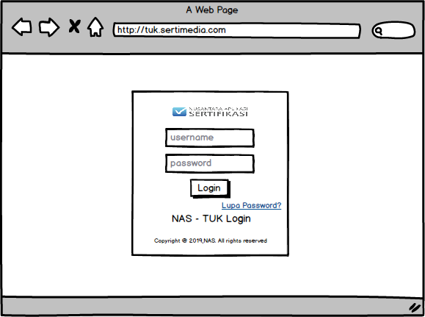

1. **Home** Menu

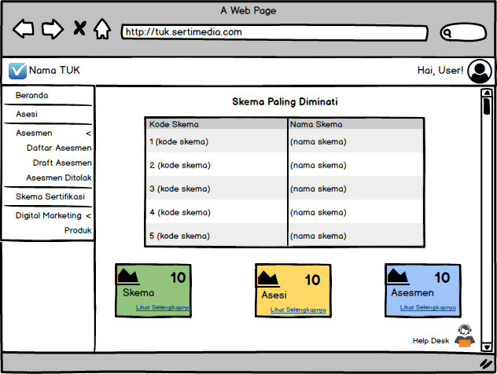

1. **Asesi** Menu
2. **Asesi List Page**

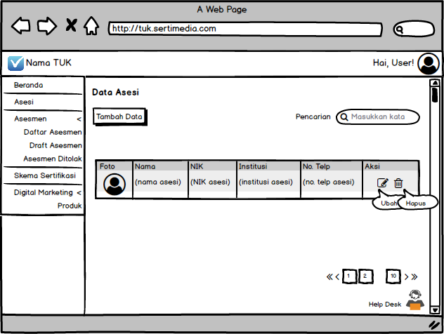

1. **Add**  **Data**  **asesi** page

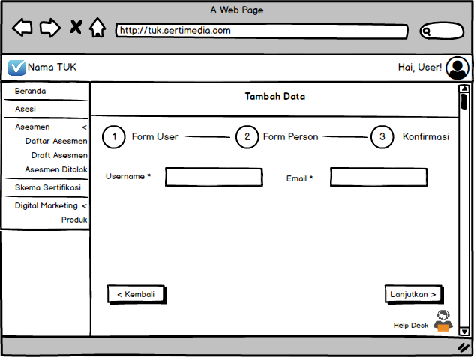

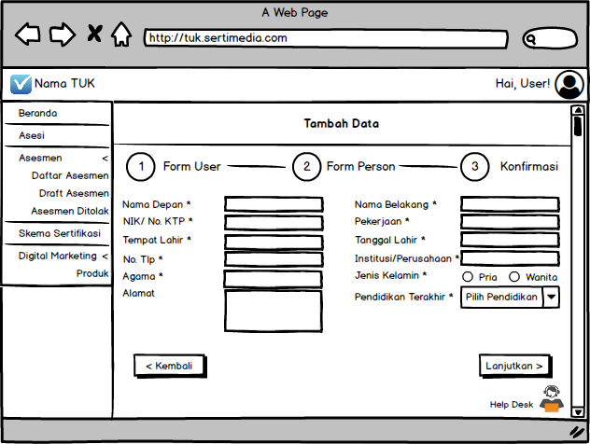

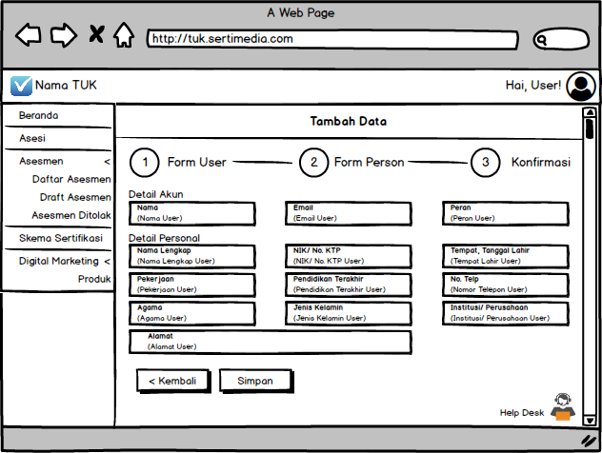

1. **Edit Data** page **asesi**

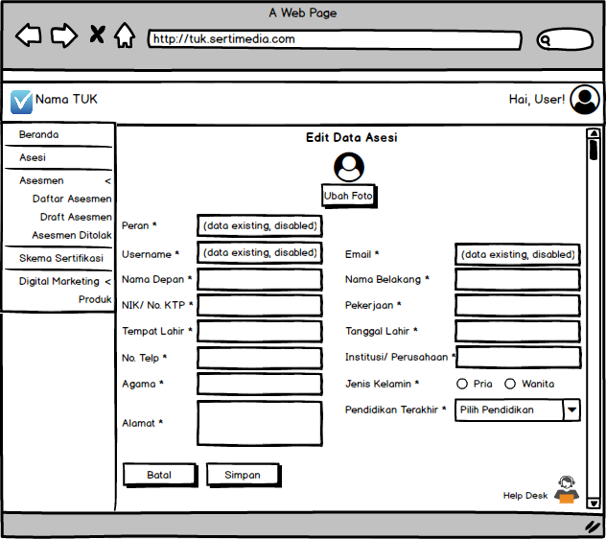

1. **Assessment Menu**
2. **Assessment List Page**

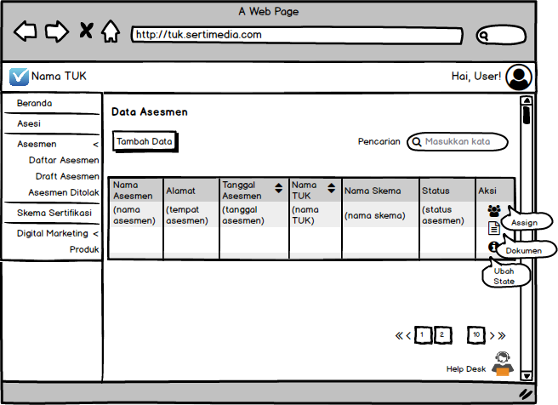

1. **The add**  **Assessment** page

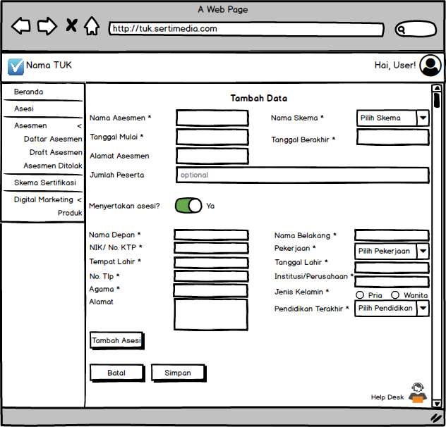

1. **The Assign (asesi)** page

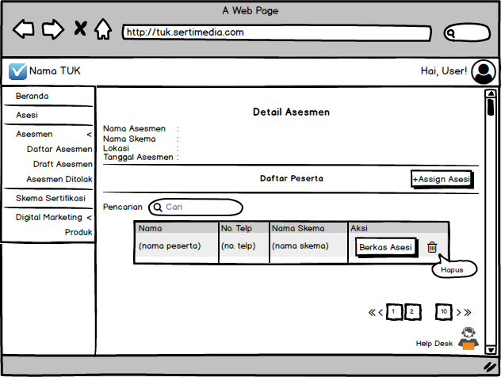

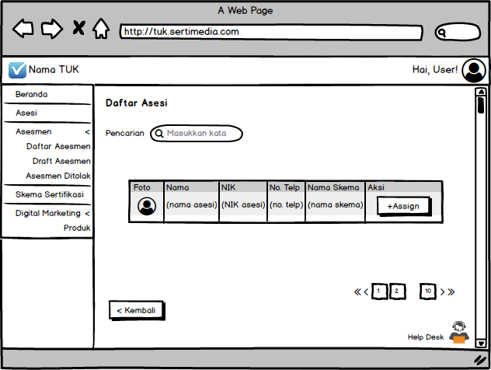

1. **Asesi**  **File** page

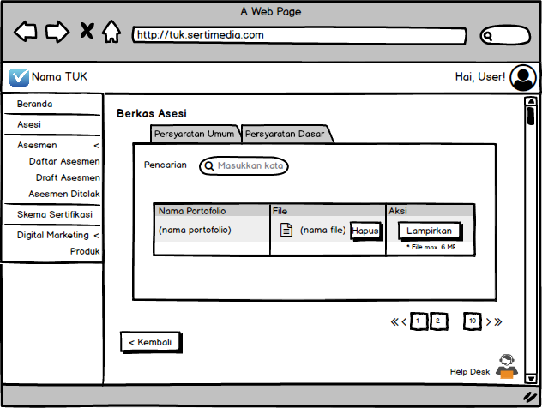

1. **Document page**  **(letter**  **Permohonan**  **Assessment)**

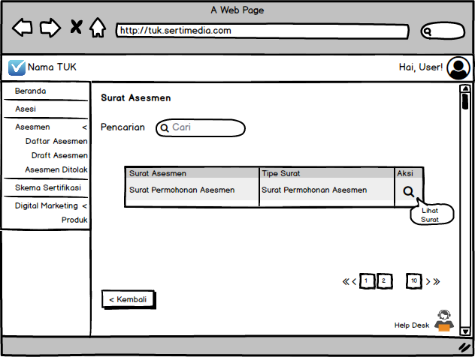

1. **View**  **State** page

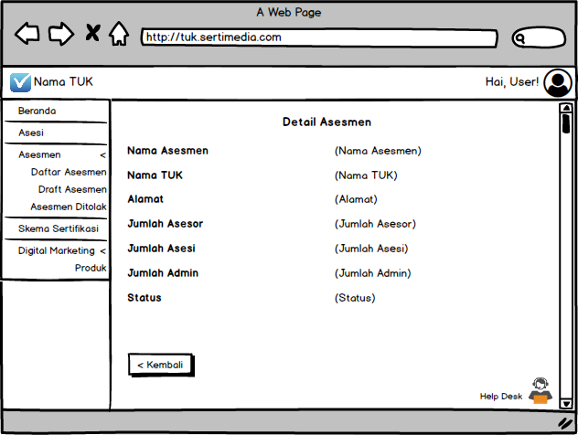

1. **Page Draft**  **Assessment**

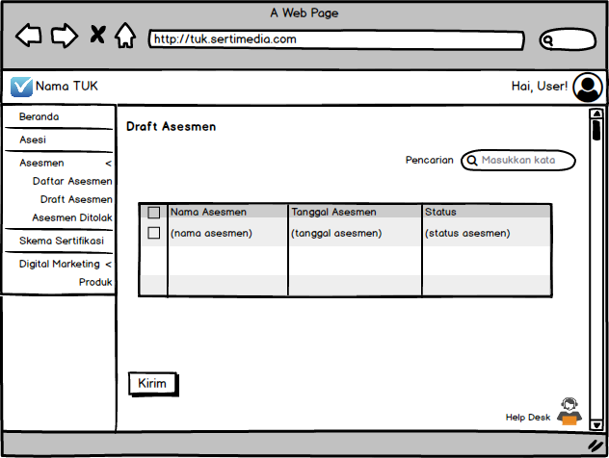

1. **Assessment** Page **denied**

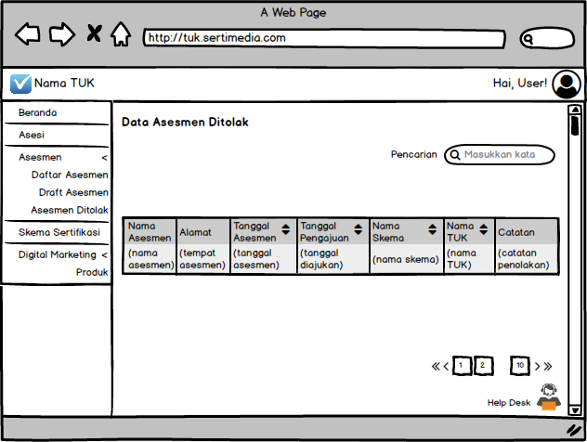

1. **Certification Scheme Menu**

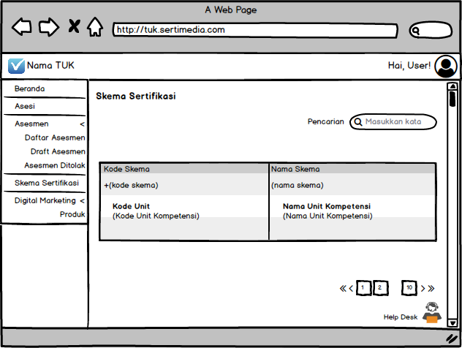

1. **Menu Digital Marketing**
2. **Product** Page

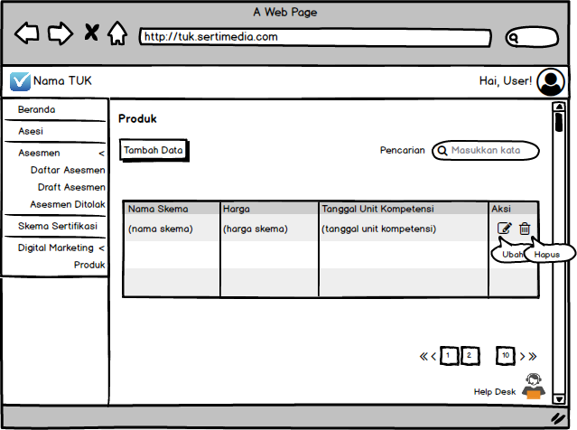

1. **Product Add**  page

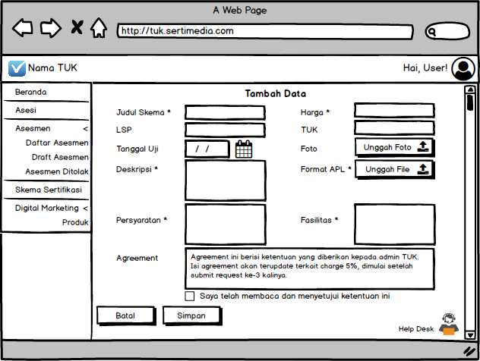

1. **Product Edit**  **Produk** page

